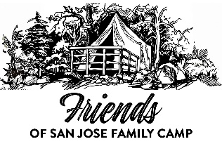
Friends of San Jose Family Camp
2026 Annual Membership Signup / Renewal Form

Name ___________________________________________________
Address _________________________________________________
City ___________________________ State ______ Zip __________Phone # ____________________
Email #1 __________________________________ Email #2 __________________________________
Preferred method of contact : Phone ☐ Email ☐
Members in your family –
Name ___________________________________________
Name ___________________________________________
Name ___________________________________________
Name ___________________________________________
Name ___________________________________________
Would you like to help with various volunteer projects to support camp? Tell us about your skills- ________________________________________________________________________________________________________________________________________________________________________________
Are you new to Friends? If so, welcome Friend! How did you hear about us? ________________________________________________________________________________________
Membership type: NEW ☐ RENEWAL ☐ Membership rates – Family ($50) / Individual ($25)
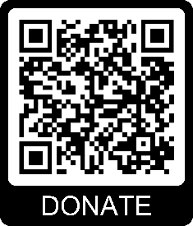
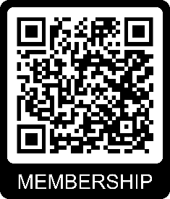
Renew your membership Mail Registration Form To: Would you like to donate
online. Scan the QR Friends of San Jose Family Camp to Friends? Scan the QR
code below- PO Box 8237 code below-
San Jose, CA 95155
Email Us:
membership@friendsofsanjosefamilycamp.org

This printed form may be sent to the above PO Box along with
payment or use the QR codes for online registration and donation.
Please visit our website for more information-
www.friendsofsanjosefamilycamp.org/membership
Thank you Friend! We appreciate your support to help preserve and improve the experience at Family Camp at Yosemite. FOSJFC is a 501(c)(3) non profit organization.

